Natal Biotech

New Perspectives Excel 2019 | Module 1: End of Module Project 1



Getting Started with Excel

# GETTING STARTED

* Open the file **NP_EX19_EOM1-1_*FirstLastName*_1.xlsx**, available for download from the SAM website.
* Save the file as **NP_EX19_EOM1-1_*FirstLastName*_2.xlsx** by changing the “1” to a “2”.

If you do not see the **.xlsx** file extension in the Save As dialog box, do not type it. The program will add the file extension for you automatically.

* With the file **NP_EX19_EOM1-1_*FirstLastName*_2.xlsx** still open, ensure that your first and last name is displayed in cell B6 of the Documentation sheet.

If cell B6 does not display your name, delete the file and download a new copy from the SAM website.

* PROJECT STEPS

1. As the operations manager, you use Excel to maintain project data and schedule facilities usage. You are finalizing the *Projects* and *Scheduling* worksheets for the current week.   
     
   Begin on the *Projects* worksheet by increasing the font size of the range A2:A3 to 12 point.
2. Enter the values shown in Table 1 into the corresponding cells in the range B8:C11.

* Table 1: Data for the Range B8:C11

|  |  |  |
| --- | --- | --- |
|  | B | C |
| 8 | **Yvonne Byrom** | **2018** |
| 9 | **Fiona Hernandez** | **2020** |
| 10 | **Taisha Zygmont** | **2021** |
| 11 | **Jared Sandor** | **2021** |

1. Adjust the width of Column B using AutoFit.
2. In cell E6, enter the following:  
   **AFS51EZ21**  
     
   Select the range E6:E11, and then use the Flash Fill button (in the Editing group on the Home tab) to automatically enter codes into the remaining cells in the range. (*Hint:* You must use the Flash Fill button to properly receive credit for this step.)
3. Hide Column C.
4. Switch to the *Scheduling* worksheet. In cell A3, change the cell content to **Week of February 22, 2021** (instead of Week of February 15, 2021).
5. Cut the contents and formatting of the range D15:E18 and paste them into the range A13:B16.
6. In cell B13, create a formula using the **COUNT** function to determine the number of projects that have booked facility hours by counting the values in the range **C6:C11**.
7. Adjust the zoom level of the *Scheduling* worksheet to 120%.
8. Change the page orientation of the *Scheduling* worksheet to Portrait.
9. Some weeks you need to track facilities-related information, but that's not necessary this week. Move the *Facilities* worksheet between the *Projects* and *Scheduling* worksheets, then hide the *Facilities* worksheet.
10. When you hand off your worksheet to the facilities team, another colleague will add information about contractors working on site. To create a placeholder worksheet for this data, insert a new worksheet in the workbook, rename the worksheet **Contractors**, and if necessary, move the new worksheet after the *Scheduling* worksheet.

Your workbook should look like the Final Figures on the following pages. Save your changes, close the workbook, and then exit Excel. Follow the directions on the SAM website to submit your completed project.

* Final Figure 1: Projects Worksheet

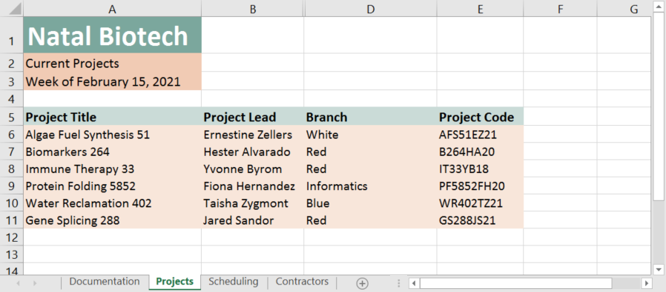

* Final Figure 2: Scheduling Worksheet

